Keep Growing: Resources for Year 6 Transitioning
to Secondary School
Purpose |  | People |  | Prayer | x | Place |  | Plan |  | Progress

Offering Worries to God
During any time of change, we maybe worried or scared about different things. The Bible is full of reminders that we can offer our worries to God.
- “Leave your troubles with the Lord,” (Psalm 55.22)
- “I am the Lord your God; I strengthen you and tell you, ‘Do not be afraid; I will help you.’” (Isaiah 41.13)
- “Come to me, all of you who are tired from carrying heavy loads, and I will give you rest.” (Matthew 11.28)
- “Leave all your worries with him, because he cares for you.” (1 Peter 5.7)
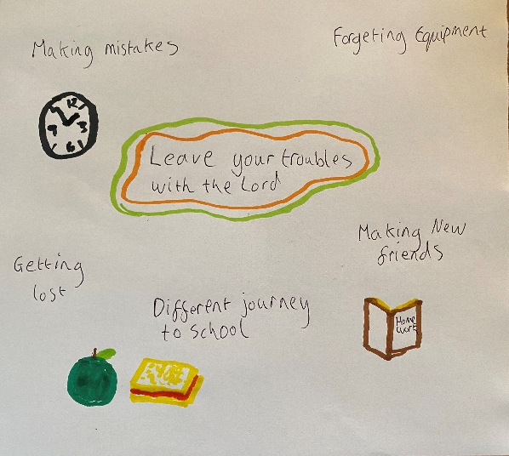
Pick one of the quotes and write it in the middle of a piece of paper. Around the quote write or draw a symbol that represents what you are worried about.
When you are finished you may wish to hold your piece of paper and say or think of a prayer offering all your worries to God.
You may want to keep your piece of paper and add to it, or you can screw it into a ball and as you throw it away, think of your worries being shared with God.

