Keep Growing: Resources for Year 6 Transitioning
to Secondary School
Purpose |  | People | 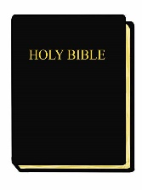 | Prayer |  | Place |  | Plan |  | Progress | X
Date:
Bible Passage:

Bible Study Notes
Prayer Before Reading (What do I want to ask God before reading?):

Thinking While Reading (What can I learn about God from this Bible passage?):

Applying What I Read (How can I use what I have read to live well?):

Questions After Reading (What questions do I have now I have read this passage?):

