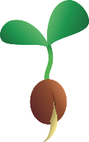
Keep Growing: Resources for Year 6 Transitioning
to Secondary School
Purpose |  | People |  | Prayer |  | Place |  | Plan |  | Progress | X

Big Questions
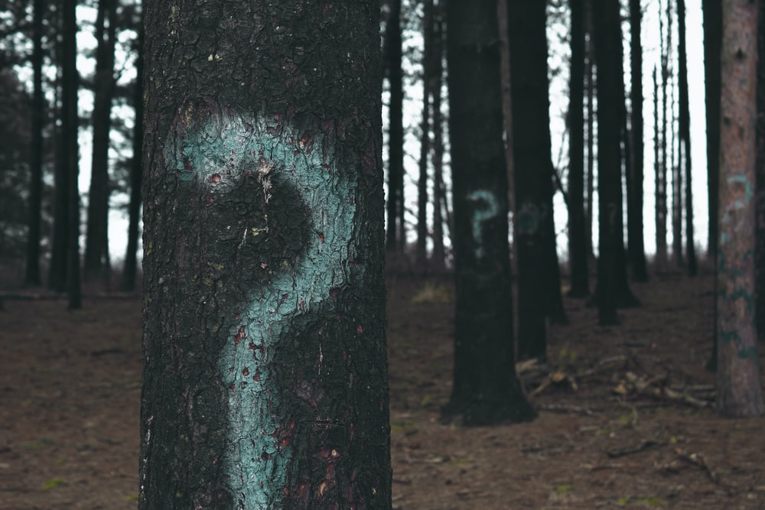
What are your ‘Big Questions’ about life, God, yourself, the world?
Write some of them here:

Who could you talk to about these questions?
What might help you think about these questions? Prayer, reading the Bible, silence and contemplation, the lives of role models, creativity

