Keep Growing: Resources for Year 6 Transitioning
to Secondary School
Purpose |  | People |  | Prayer | X | Place |  | Plan |  | Progress
Circle of Control, Influence and Concern
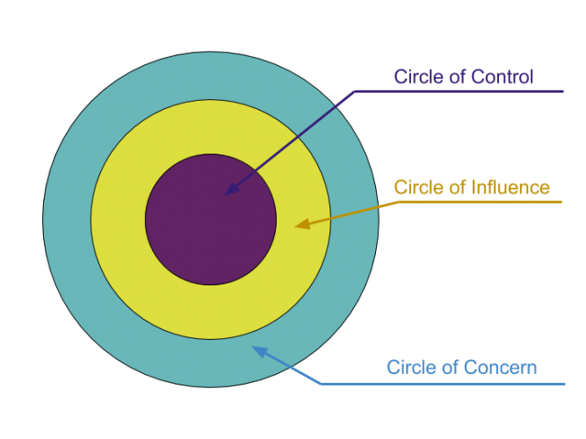
Use this when you are feeling nervous about something new or unfamiliar to guide your prayers:

Circle of Control- what is in your control? Ask for wisdom and courageous to be able to do it.

Circle of Influence- who are the people you can talk to and do this with? Ask for favour and friendship with others

Circle of concern- what is really bothering you and you are not in control of? Ask for peace to let go of wanting to control it and trust that it is in God’s hands.

