Keep Growing: Resources for Year 6 Transitioning
to Secondary School
Purpose |  | People |  | Prayer |  | Place | X | Plan |  | Progress

Creating a Sacred Space
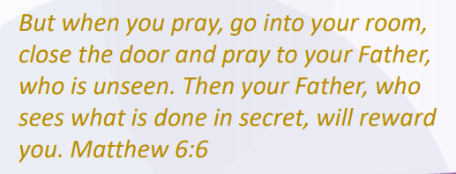
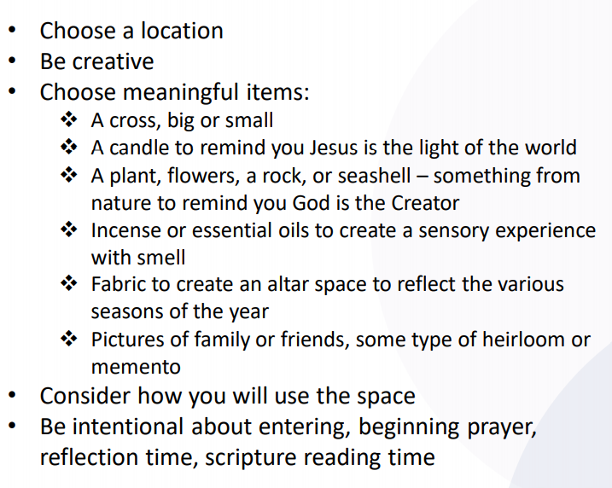
Is there somewhere that you find peaceful and relaxing? Could you use some images or objects to make it into a sacred space for you to pray, reflect or be silent? Use the guidance to the left to help you create a special place for you and God.
The Bible says this about finding a place to be quiet and pray:

