Keep Growing: Resources for Year 6 Transitioning
to Secondary School
Purpose |  | People |  | Prayer |  | Place |  | Plan |  | Progress | X

Experiencing the Bible: Spiritual Imagining
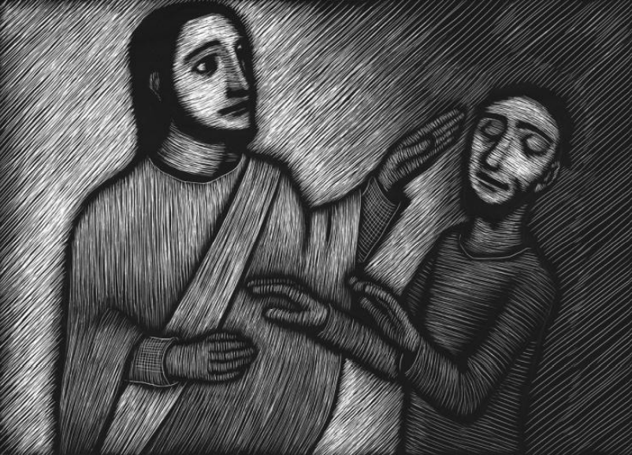
St Ignatius of Loyola developed many spiritual practices to help people connect with God through prayer and the Bible. One of these exercises was ‘spiritual imagining’ and involves the person imagining they are there in the Bible story with Jesus. This is to help Jesus feel more real to the person and to make them feel connected to Him more deeply. Try it!
- Choose a Bible passage from the Gospels so that Jesus is in the story
- Read the story to yourself
- Imagine you are there in the story
- Think about these things: Where are you standing?
  - Can you see Jesus? Where is He?
  - What can you see/hear/touch/taste/smell?
  - How does being with Jesus in this story make you feel?
- What have you learned about Jesus today?
- What has being with Jesus done in your heart?
- How has this Bible passage inspired you to serve or help others?

