**Keep Growing: Resources for Year 6 Transitioning**

**to Secondary School**

|  |  |  |  |  |  |  |  |  |  |  |  |
| --- | --- | --- | --- | --- | --- | --- | --- | --- | --- | --- | --- |
| **Seedling, Seed, Growth, Plant, Green, Agriculture, SoilPurpose** |  | **Seedling, Seed, Growth, Plant, Green, Agriculture, SoilPeople** |  | **Seedling, Seed, Growth, Plant, Green, Agriculture, SoilPrayer** | **X** | **Seedling, Seed, Growth, Plant, Green, Agriculture, SoilPlace** |  | **Seedling, Seed, Growth, Plant, Green, Agriculture, SoilPlan** |  | **Seedling, Seed, Growth, Plant, Green, Agriculture, SoilProgress** |  |

**Year 6 Life Labyrinth**

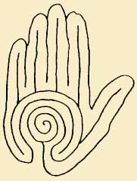











Reflection Question 5: What is God saying to me as I wait?

Reflection Question 4: Where do I see myself in the future?

Reflection Question 3: What has my journey been like so far?

Reflection Question 2: What am I looking for in life?

Reflection Question 1: Who has God made me to be?