Keep Growing: Resources for Year 6 Transitioning
to Secondary School
Purpose |  | People |  | Prayer |  | Place |  | Plan |  | Progress | X

Living Well: The Fruits of the Spirit
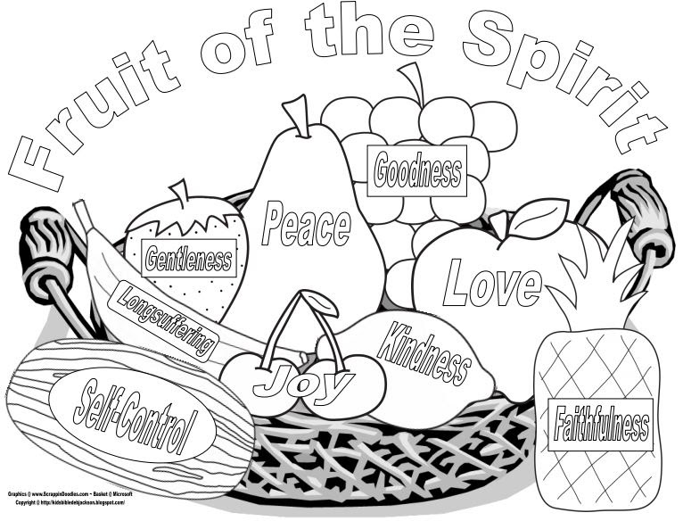
Christians use the Bible to help them to live well. The Fruits of the Spirit are one of the things that people aspire to when wanting to live God’s way.
Have a look at the different fruits. Are there some you feel you are already growing well in? Colour those in. Are there any that you need help to flourish in? Spend some time in prayer or quiet reflection sharing your intention to grow in those things and asking for help. Colour them in as you feel yourself growing.

