Keep Growing: Resources for Year 6 Transitioning
to Secondary School
Purpose |  | People |  | Prayer |  | Place |  | Plan | X | Progress

Planning for Spiritual Encounters
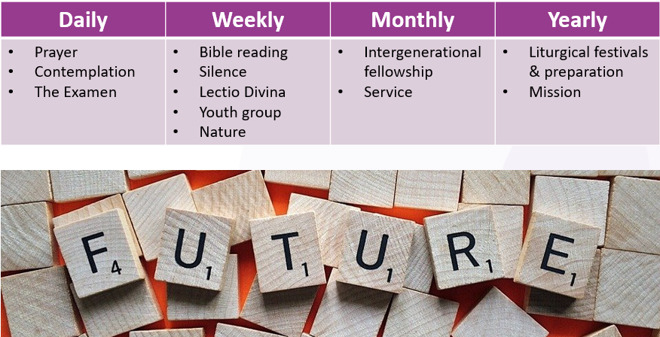
Look at the things on this list. Are there any things you don’t do currently but that you might like to do to help you keep growing spiritually?
Who might help you?
- Teachers
- Parents
- Vicar
- Friends
- Groups

