Keep Growing: Resources for Year 6 Transitioning
to Secondary School
Purpose |  | People |  | Prayer | X | Place |  | Plan |  | Progress

Prayer Using Images
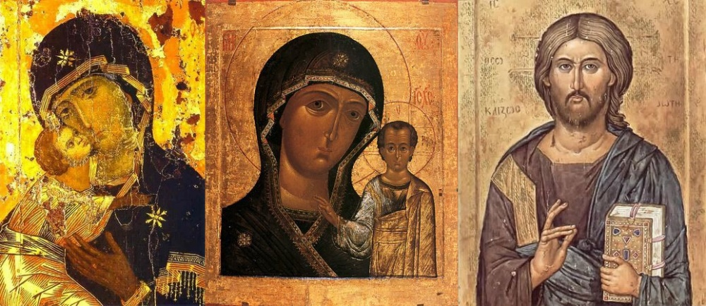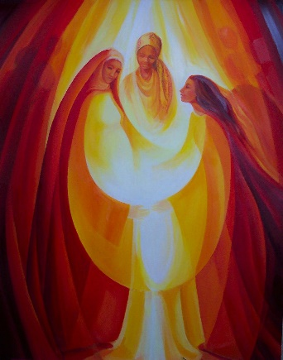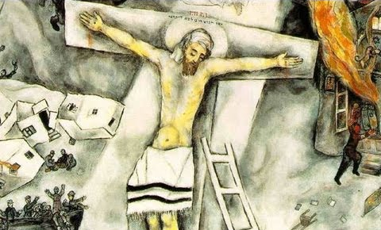
Sometimes, having an image in front of you to focus on while you pray can be helpful. The tradition of icons (like the three on the left) has been a part of Christianity for a very long time. Christian artists in modern times have also tried to capture some of the ideas, concepts and beliefs of Christianity and these images can provide a focus for prayer and reflection too.
Choose one of these images to focus on or use a search engine to search for images you could use in prayer:
- Search for a Christian word or concept
- Search for a specific Bible verse or story
- Search ‘Christian icons’

