Keep Growing: Resources for Year 6 Transitioning
to Secondary School
Purpose | X | People |  | Prayer |  | Place |  | Plan |  | Progress

Psalm 139: Fearfully and Wonderfully Made
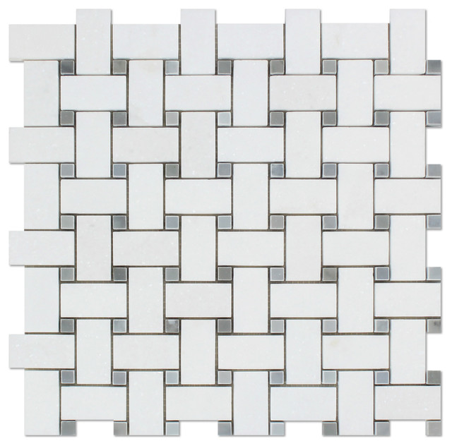
For you created my inmost being;
you knit me together in my mother’s womb.
I praise you because I am fearfully and wonderfully made;
your works are wonderful,
I know that full well.
Psalm 139
Read the whole psalm in your Bible. Use the weaving above to write and draw about yourself- the unique person God made you to be.

