Keep Growing: Resources for Year 6 Transitioning
to Secondary School
Purpose |  | People | X | Prayer |  | Place |  | Plan |  | Progress

Reconciliation: Living God’s Way with Others
There will be times when you have conflict and fall out with others. Reconciling and forgiving are not easy things. Use the grid below to follow Archbishop Desmond Tutu’s Fourfold Path to Forgiveness
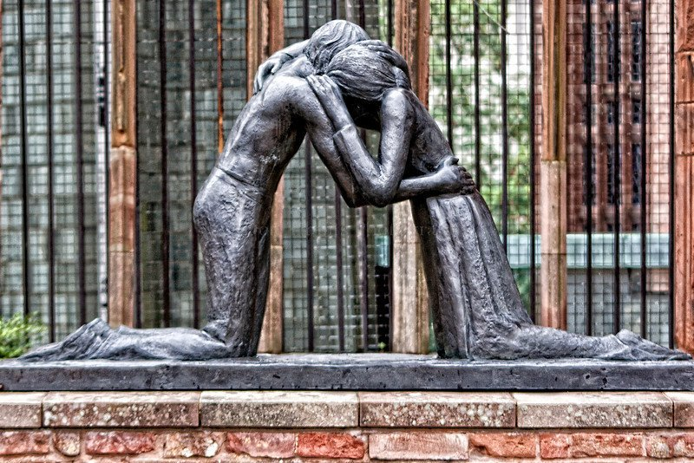
The Reconciliation Statue in the ruins of Coventry Cathedral is a wonderful reminder of the power of forgiveness and reconciliation.

Write or draw in the boxes as you work through the pathway.

