Keep Growing: Resources for Year 6 Transitioning
to Secondary School
Purpose |  | People |  | Prayer | X | Place |  | Plan |  | Progress
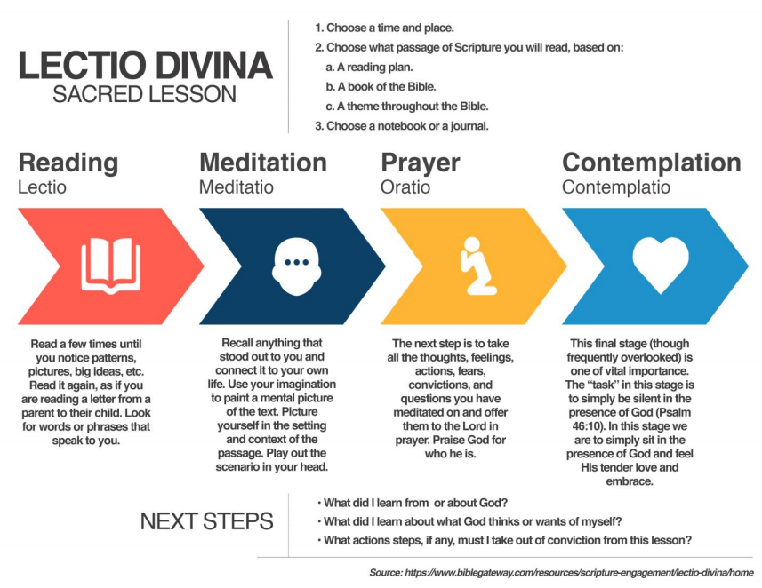
Resting with the Bible: Lectio Divina
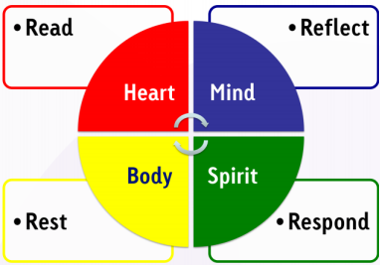
Lectio Divina is a way of reading the Bible prayerfully and with contemplation. Follow the instructions on the left. Use a piece of paper or a notebook to write or draw your thoughts, feelings, ideas and questions as you go through the different steps.
Lectio Divina is good for you heart, your mind, your body and your spirit. It is a good way to take care of all of you and connect with God!

