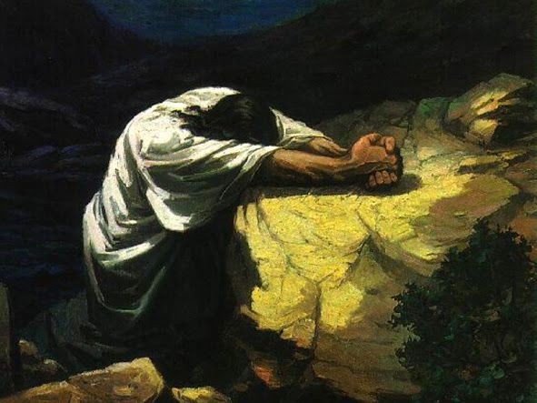
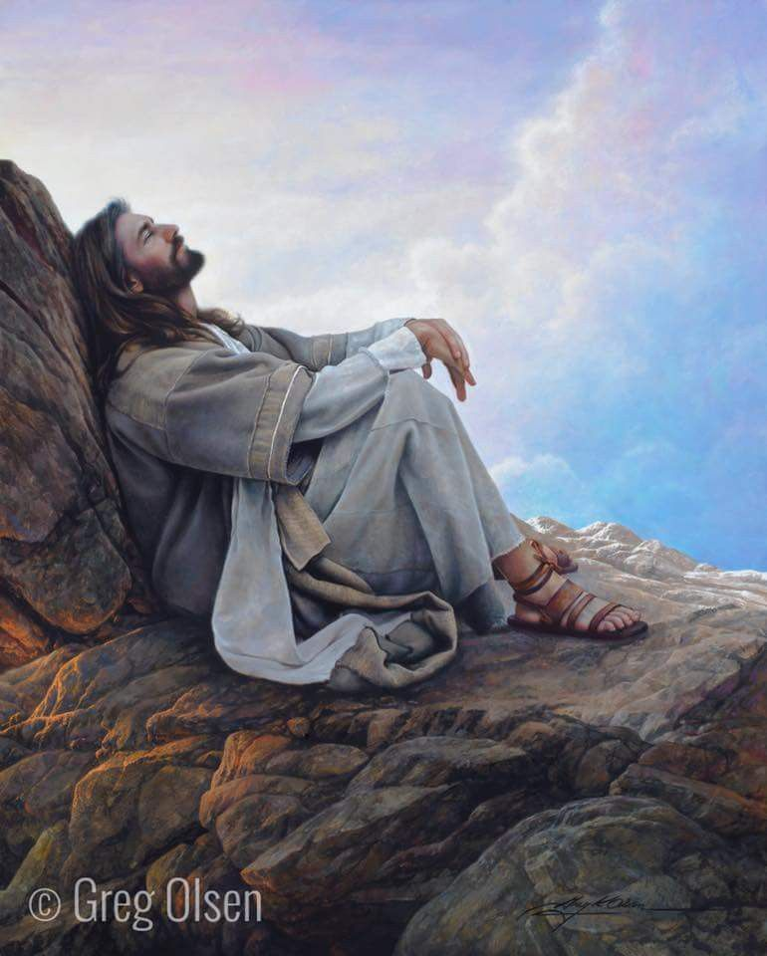
Keep Growing: Resources for Year 6 Transitioning
Solitude
Reflection
Responding
to Secondary School
Purpose |  | People |  | Prayer |  | Place | X | Plan |  | Progress

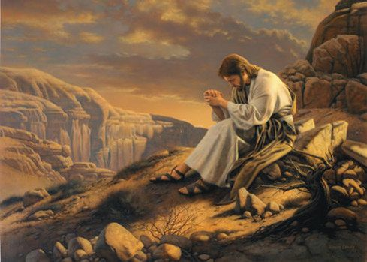
Silence and Solitary Places
Has being alone with God made you want to do something?
But when you pray, go into your room, close the door and pray to your Father, who is unseen. Then your Father, who sees what is done in secret, will reward you.
Matthew 6:6
Jesus frequently chose to be alone. We do not know what he did during these times of solitude but it is a fair assumption to believe he reflected and prayed.
Following these times, he returned to the crowds and went on to react with kindness and compassion towards others. Take some time to be silent and solitary.
But when you pray, go into your room, close the door and pray to your Father, who is unseen. Then your Father, who sees what is done in secret, will reward you. Matthew 6:6

