Keep Growing: Resources for Year 6 Transitioning
to Secondary School
Purpose |  | People |  | Prayer | X | Place |  | Plan |  | Progress | X

The Armour of God
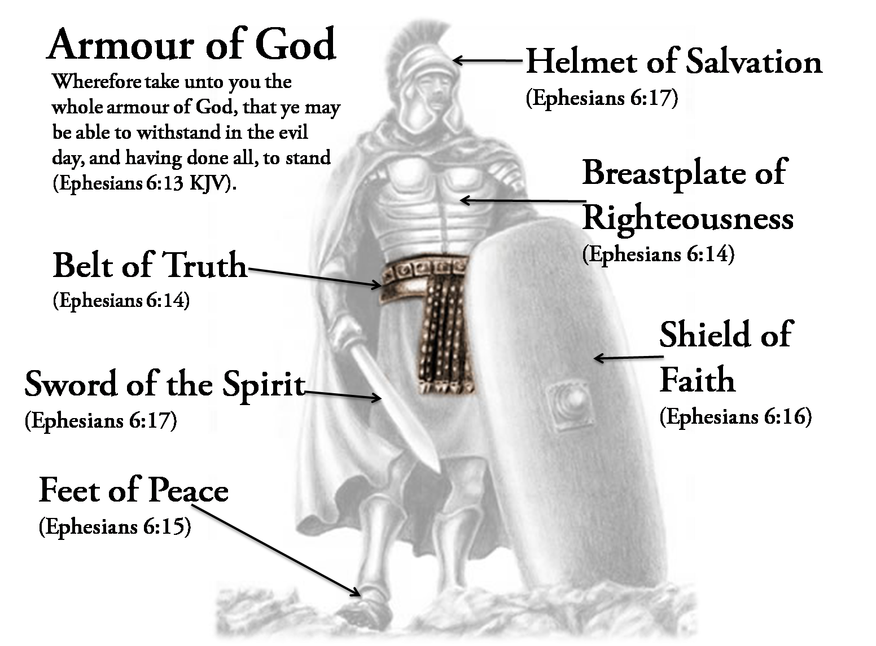
Paul’s Letter to the Ephesians reminds the Christians in Ephesus to ‘put on the armour of God’ on a daily basis.
Some days you might need one part of the armour more than others.
What do you really need to out on today?
Can you ask God to help you with putting on your armour?

Read Ephesians Chapter 6

