Keep Growing: Resources for Year 6 Transitioning
to Secondary School
Purpose | X | People |  | Prayer |  | Place |  | Plan |  | Progress

The Beatitudes- Living Well God’s Way
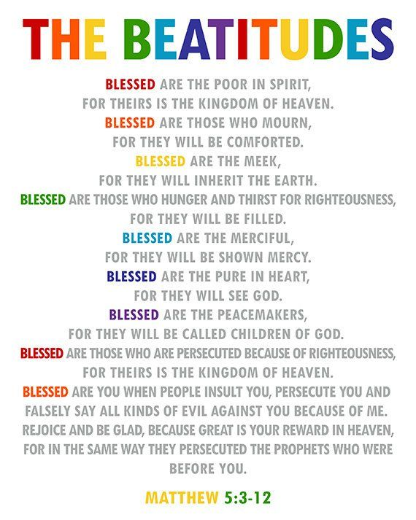
In the nine boxes draw what each of the Beatitudes means to you and your way of living.

