Keep Growing: Resources for Year 6 Transitioning
to Secondary School
Purpose |  | People |  | Prayer |  | Place |  | Plan | X | Progress

The Liturgical Calendar
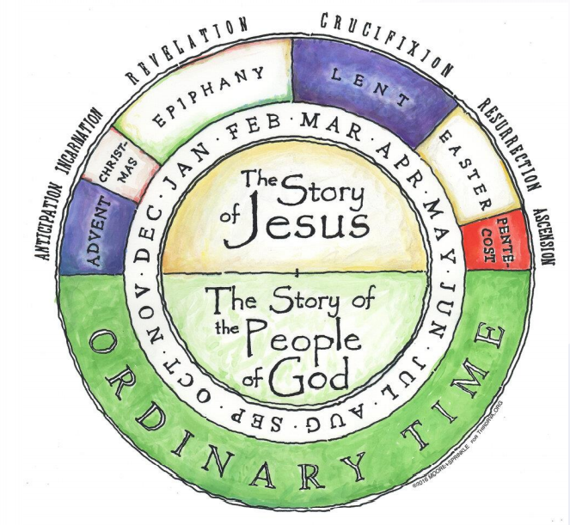
The Liturgical Calendar shows us how the different seasons within the year help us to explore the big story of Christianity. There are two halves to the church year- one half that explores the life and teachings of Jesus and one that is ‘ordinary time’- a time of ‘green for growing’!
Purple times, like Advent and Lent, are times of preparation, where we get ready for the celebrations of Christmas and Easter.
Gold times are special times of celebration- Christmas and Easter.
Red times are times of joy- like Pentecost, the birthday of the church.
In green times you grow- use these Y6 resources, read your Bible, pray, spend time in quiet reflection, talk to trusted adults and friends on a faith journey too.
Use this diagram to help you keep track of where we are in the liturgical cycle. Find the rhythm of preparation, reflection and celebration for yourself.

