Keep Growing: Resources for Year 6 Transitioning
to Secondary School
Purpose |  | People |  | Prayer | X | Place |  | Plan |  | Progress

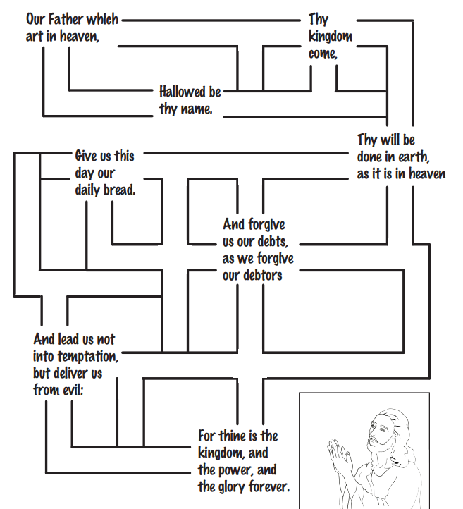
The Prayer Jesus Taught Us: Praying the Lord’s Prayer
The Lord’s Prayer is the prayer Jesus taught His disciples. If you aren’t sure how to start praying or what to pray, this is a good place to start. It praises God, asks for His help, says sorry for wrong choices and asks for protection. Use the maze to find your way through the prayer slowly with your finger, saying each part and pausing to reflect before moving on.

